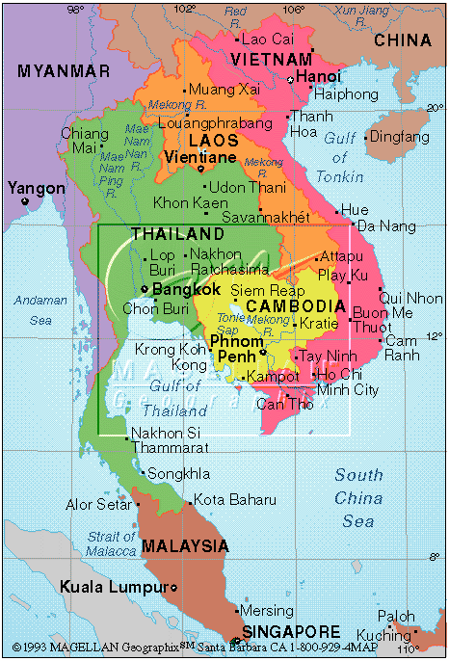
Vietnam War Guided Notes
Phase One - War of ____________________________
Vietnam is a _______________________________ colony. Along with Laos and Cambodia, it is known as _________________________________________.
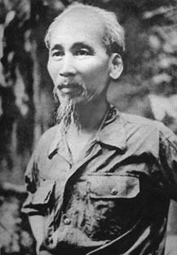
Vietnam fights for independence from France during _________________.
The fight for independence is led by _________________________________________________, a communist!
Ho receives support from the USSR and _____________________________________________.
The French are defeated at _________________________________________________.
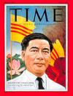
Vietnam divided at the ___________________________________. Communist North led by Ho and democratic South led by ____________________________________________________.
Free elections are to be held in ______________________.
U.S. sees Vietnam as a ____________________________ that must not fall!
Many South Vietnamese do not like Diem because he is Catholic, speaks French and __________________________________________________________prisoners.
Resistance leads to the creation of the ________________________________________ in South Vietnam. These “freedom fighters” are also known as ______________________________.
U.S. supports the overthrow of Diem in ________________________________.

Phase Two - Increased U.S. Involvement!
Per U.S. policy of “containment”, ______________________ AND _______________________ send in MILITARY ADVISORS.
In 1964, 2 U.S. destroyers on a spying mission are supposedly fired upon by North Korea. This is known as the ___________________ ______ __________________________ Incident.
This incident is used as an excuse for Johnson to send in military troops to Vietnam, to stop the communist threat to South Vietnam.
1965 Operation Rolling Thunder – Sustained American _________________________ ____________ on Vietnam.
_________________________ tons of bombs dropped in about __________________ years.
US ground forces arrive! Nearly _________________________ by the end of 1965.
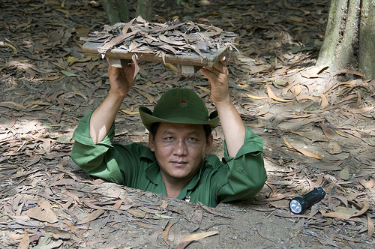
In spite of an increase in troops and bombs (known as __________________________), the US experiences a lack of success against Vietcong military tactics known as
_____________________________ tactics and revolutionary mentality of the Vietcong soldiers.
US is unsuccessful in shutting down the communist supply route known as the ______________________________________________________. The route ran through the neighboring countries of __________________ and ________________________.
In 1968 the _______________ _________________________ was technically a loss for the Vietnamese but it proved to the American people that the war was not even close to ending! To many it was seen as an _________________________ war.
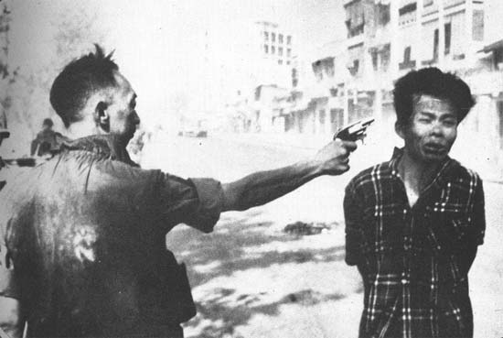
This perception increased as Vietnam was the first ________________ War. Americans could see the violence at home every day.
Americans could see the impact on Vietnamese as the U.S. increased bombing, increased the release of defoliants such as __________________ _____________________, and the dropping of Napalm!
The attack on the village of ________________ _______________ is seen as an example of American brutality towards the Vietnamese.
Do you feel it was murder or were the soldiers simply following orders? _____________________________________________________________
Hippies and Flower Children were part of the ________________________________ that led protest movements against the war.
Describe a Hippie: ________________________________________________________________________________________________________________________________________________________________________
Americans were increasingly distrustful of the Government, this was known as a _________________________ _____________________. LBJ chooses not to run in 1968 and Nixon is elected on a platform of ________________________ ___________________ ___________________.
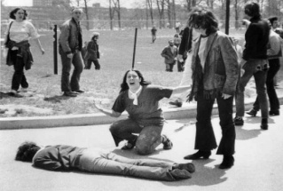
Nixon’s secret plan to end the war was known as ___________________________________.
4 students are shot dead at _______________ ________________ by National Guardsman!
U.S. removes troops on _______________________________________________.
Classified government documents stolen from the Pentagon exposed that the government was not being entirely truthful to Americans. These Papers were known as the __________________________.

Who wins the Vietnam War? ________________________________________
Why do they win? __________________________________________________________________________________________________________________________________________________________________________
What does the War Powers Act allow the president to do? _________________________________________________________________________________________________________________________________________________________________________
